Student Name | G. Manasa
Student Registration Number | 241U1R3007 | Class &Section: CSE(DS)
Study Level: UG/PG | UG | Year &Term: I & II
Subject Name | Digital Electronics

Name of the Assessment | Reflective Journal -6
Date of Submission | 17-08-2025

Reflective Journal Template
Journal Entry Guidelines | Description
1. Experience (Class Content) | Briefly describe the topics or concepts discussed during the class.
2. Feelings (Emotional Reactions) | Share your emotional reactions and thoughts during the class.  How did you feel while learning this theory?  Did the class evoke specific emotions or questions?
3. Learning (Key Insights) | Reflect on what you learned from the class.  Highlight the key insights or fundamental concepts you gained from the class.
4. Application (Practical Use) | Describe how you plan to apply the theory you've learned in real-life situations or in your academic/career endeavours.  Explain the practical utility of this theory.

Sample Journal Entry

Date | 17-08-2025
Journal Entry Topic | Combinational Logic Design
1. Experience (Class Content) | In this module I learned about Combinational Logic Design like looking inside the brain of a digital system. Before, I thought computers, calculators, and mobiles worked like magic. But now I know that behind every task, there are small logic parts working together. There were so many diagrams, truth tables, and equations with letters like A, B, C, X, Y, and different gate symbols. At first, it was a bit confusing, but when I studied step-by-step, I understood that each symbol and table was showing how inputs turn into outputs.  When I practiced Half Adder and Full Adder, it felt like solving small maths problems, but instead of normal numbers, I was using binary (0s and 1s). When I learned subtractors, I found the borrow part new and interesting. Changing a problem into a truth table, then into equations, and finally into a circuit diagram felt like solving a puzzle step-by-step.  I also understood that combinational circuits do not have memory they only work on the current inputs. This makes them easier than sequential circuits but still very important.
2.Feelings (Emotional Reactions) | At first I was nervous because there were many new technical words like Boolean functions Sum of Products and Minuend. But when I studied step-by-step, I started understanding and felt less confused. Seeing truth tables match the circuit outputs made me happy, like I solved a puzzle. I got even more excited when I could design a Full Adder using two Half Adders without notes. That’s when I knew I understood it. By the end, I felt confident and happy because I could connect what I learned to real-life electronics.
3. Learning (Key Insights) | 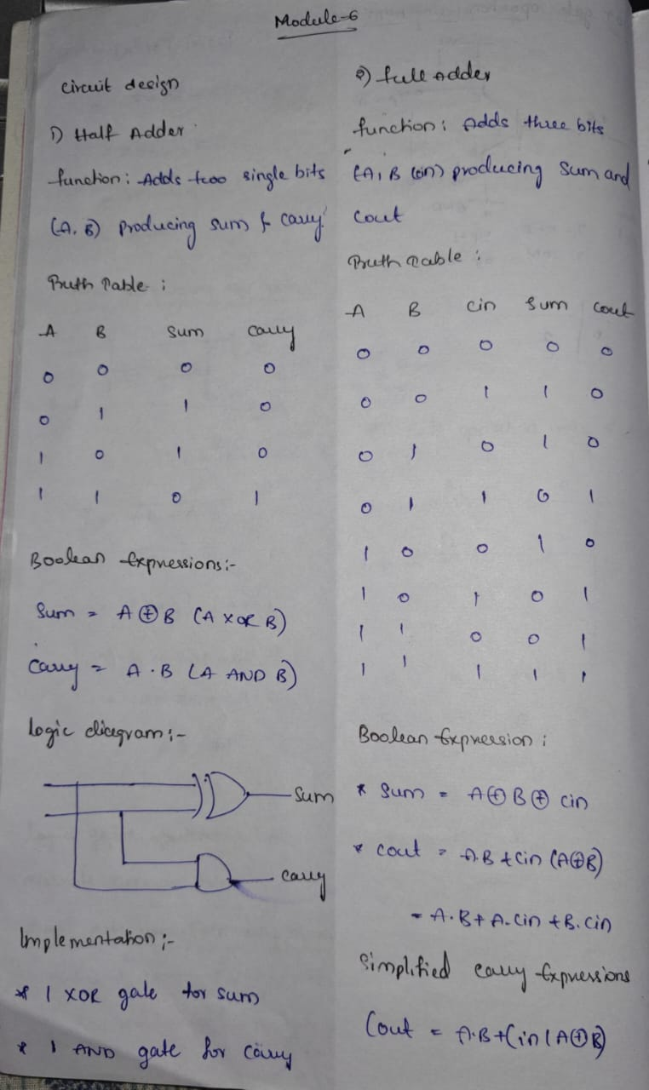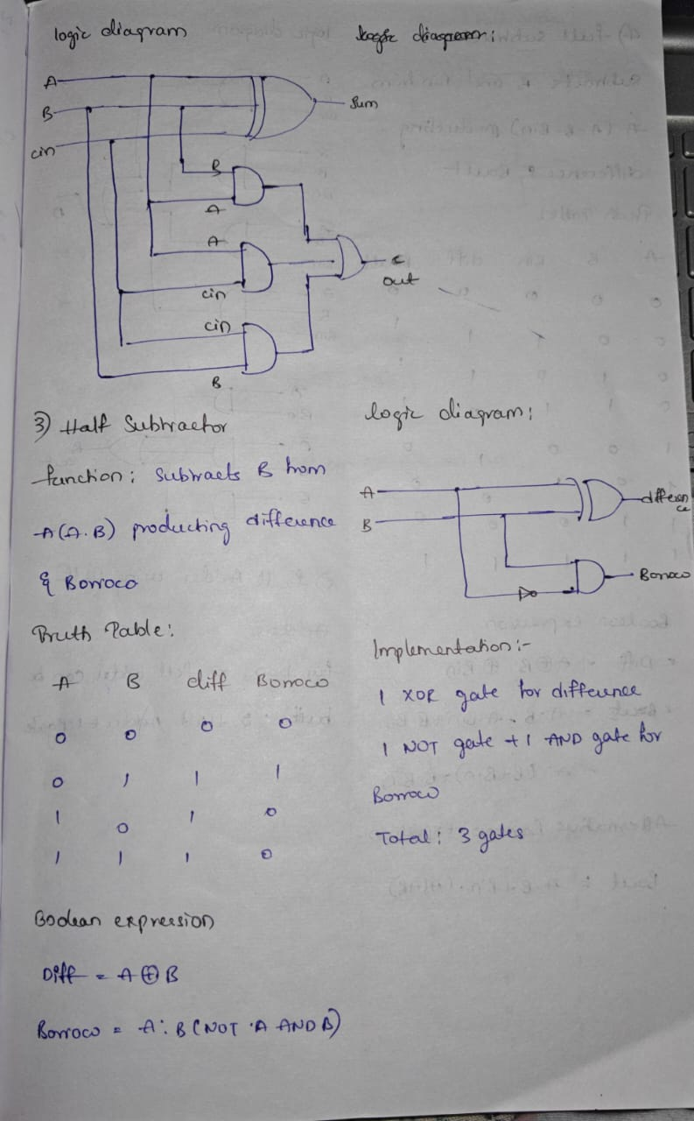  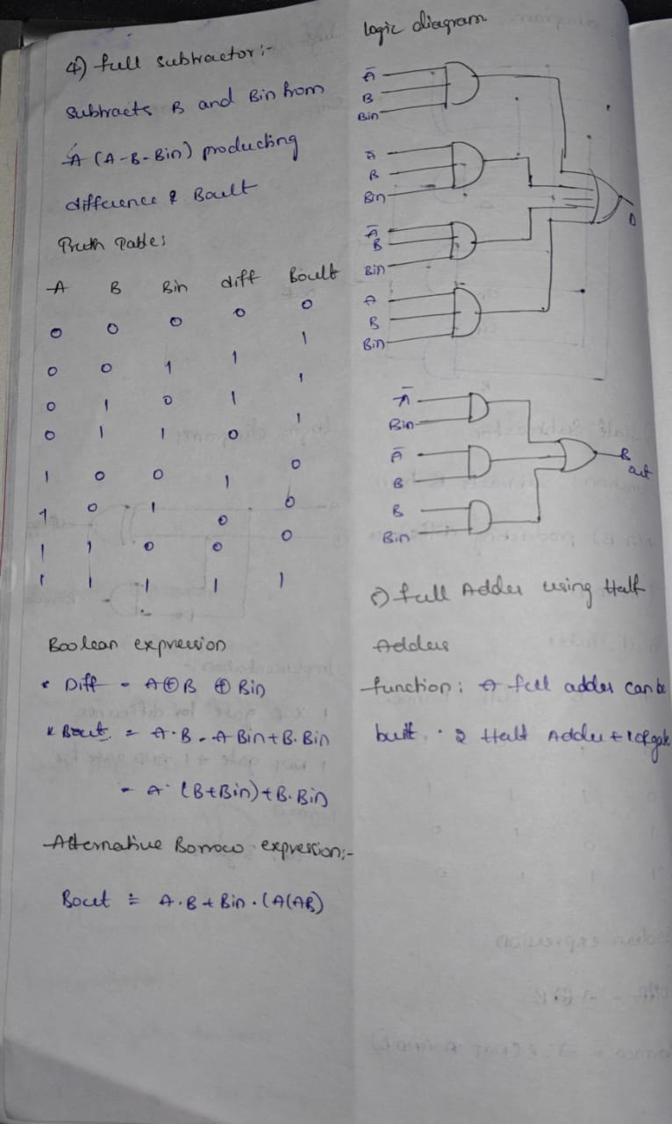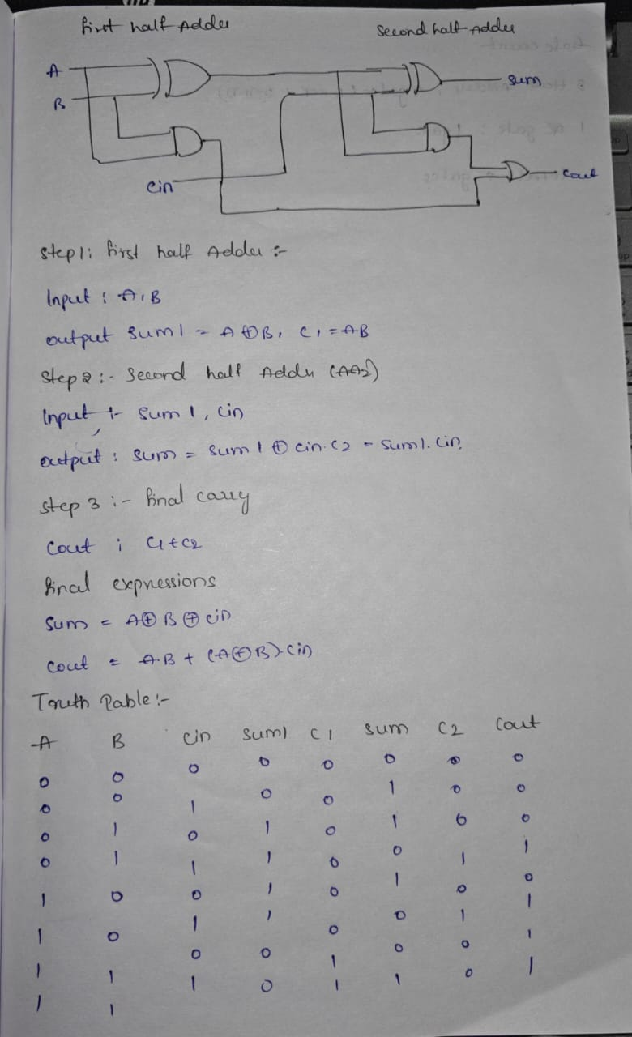  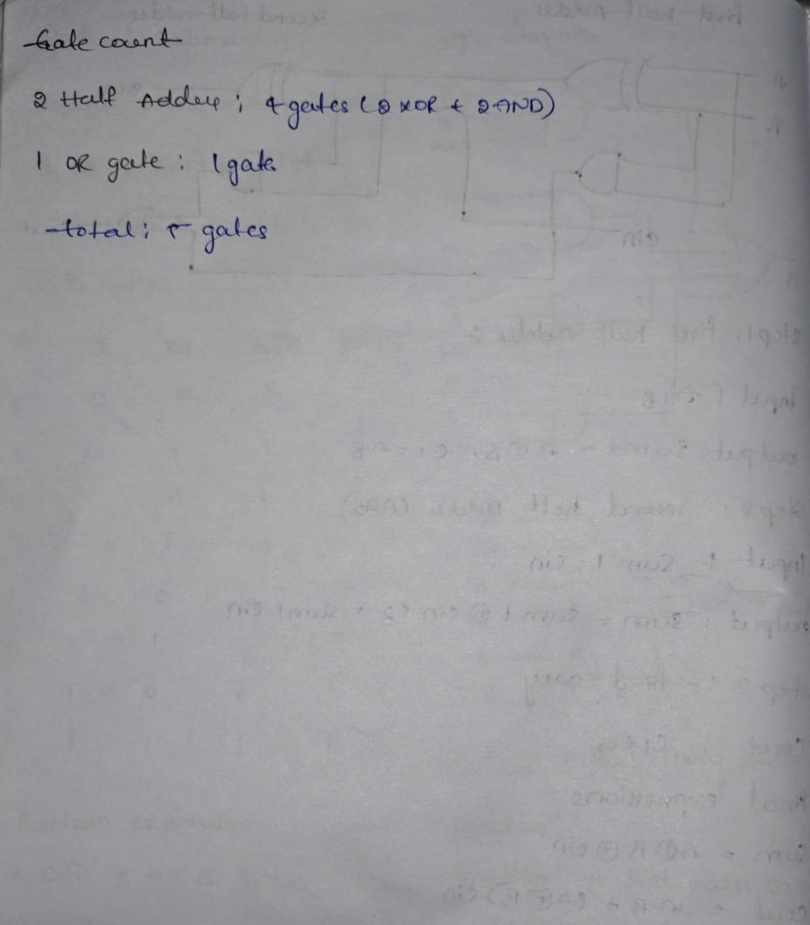
4. Application (Practical Use) | - In Processors – Adders and subtractors are essential for arithmetic operations in CPUs.  - In Calculators – The logic inside calculators uses these circuits to perform addition and subtraction quickly.  - In Digital Counters – Subtractors are used in devices that count down, like timers.  - In Measurement Devices – Subtractors are used in comparing values (e.g., temperature difference meters).  - In Communication Systems – Multiplexers and combinational logic are used to send and receive signals.  - In Robotics – Decision-making circuits often use combinational logic to process inputs and produce outputs.  - In VLSI Design – Combinational circuits are used as standard cells for chip design in modern electronics.
Conclusion | This module was not just theory it taught me to think in a clear and step-by-step way. I learned how inputs change into outputs using logic gates, and how truth tables and equations are the language of electronics. I understood that combinational circuits are the basics of how computers work. Without them, we can’t learn harder topics. I started feeling confused, then got curious, and finally felt confident and happy Now I can make simple circuits like adders and subtractors, and I know how they are used in real technology. This topic also taught me to be patient and enjoy solving problems.

